Task 1: Laplace mechanism and counting queries (4 points)
Output:
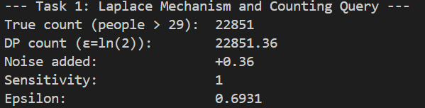
a) What is the sensitivity of this query, and why?
The sensitivity of this query is 1.
Reasoning:
Sensitivity (Δ𝑓) is defined as the maximum amount the query output can change when a single record is added to or removed from the dataset.
Since this is a counting query ("count people over 29"), adding or removing a single individual can change the count by at most 1.
- If the individual is over 29, the count changes by +1 or -1.
- If the individual is 29 or younger, the count changes by 0.
Therefore, the maximum possible change (global sensitivity) is 1.

Task 2: Contingency tables (4 points)
Output:
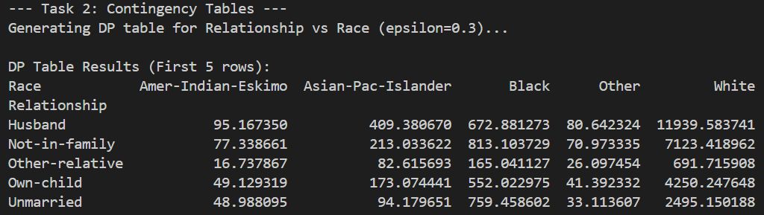
(a) Does parallel composition apply?
Answer: Yes.
Why?
The contingency table splits people into groups. Each group is one cell. One person goes into only ONE cell. The cells do not share people.
- Example:
  - Person A is "Husband" + "White" → goes to cell (Husband, White)
  - Person B is "Wife" + "Black" → goes to cell (Wife, Black)
  - They are in different cells.
When we add or remove one person, only ONE cell changes. The other cells stay the same.
This means:
- We can use the full ε for each cell.
- Total privacy cost = ε (NOT ε × number of cells).
- This is called "parallel composition."
(b) Does the number of variables matter?
For Privacy Cost: NO
The total privacy cost is always $\epsilon$. This does not change.
- 2 variables → privacy cost = ε
- 3 variables → privacy cost = ε
- 4 variables → privacy cost = ε
Why? One person still changes only one cell, regardless of the table size. So the total cost stays ε.
For Accuracy: YES
More variables = worse accuracy.
Why?
- More variables means more cells (e.g., 2 variables = 25 cells; 3 variables = 125 cells).
- More cells mean fewer people in each cell.
- We add the same amount of noise to every cell (because $\epsilon$ is the same).
Example:
- Large Cell: 1000 people + noise of 3 → error is small (0.3%).
- Small Cell: 50 people + noise of 3 → error is large (6%).
Summary:
- Privacy cost: Stays the same (ε).
- Accuracy: Gets worse with more variables.
Task 3: Differentially private selections from sets (4 points)
Output:
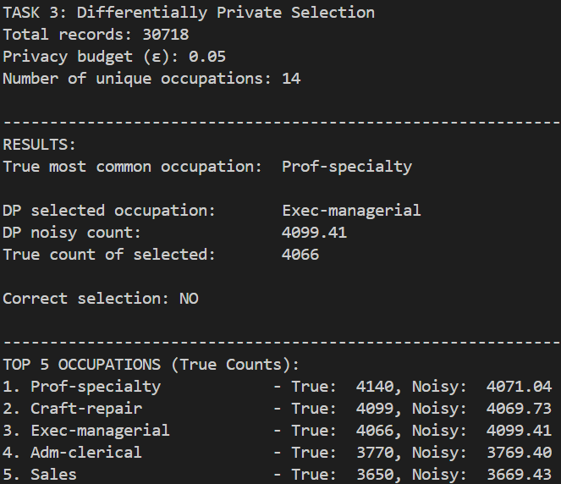
(a) What is the sensitivity of your scoring function?
Answer: The sensitivity is 1.
Why?
- Our function simply counts how many people represent each job.
- Imagine we add one person to the list.
- This person adds 1 to the count of their specific job.
- The counts for all other jobs stay the same (change is 0).
- So, the maximum change for any count is 1.
(b) What is the total privacy cost for most_common_occupation and why?
Answer: The total privacy cost is ε (epsilon).
Why?
- We use a rule called Parallel Composition.
- Think of each occupation as a separate box.
- One person fits into exactly one box (because nobody has two jobs in this data).
- Since the boxes are separate (disjoint), the privacy cost does not add up.
- We can use the full budget ε for each box without splitting it.
- Therefore, the total cost stays ε.

Task 4: Differentially private sums (4 points)
Output:
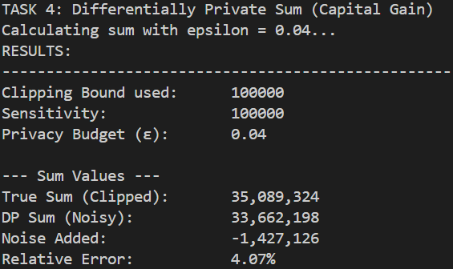
(a) What clipping parameter did you use and why?
Answer: I used a clipping parameter of 100,000.
Why?
- Domain knowledge: In the Adult dataset documentation, Capital Gain values range from 0 to 99,999.
- No bias: By clipping at 100,000, I avoid cutting off valid values, so the sum remains accurate and unbiased.
- Valid DP bound: This gives us a clean, safe upper bound on each individual's possible contribution without inspecting private data.

(b) What is the sensitivity of the query and how is it bounded?
Answer: The sensitivity is 100,000.
Explanation:
- Sensitivity $Δf$is the maximum contribution a single person can make to the sum.
- Since all values are clipped at 100,000, one person can change the sum by at most 100,000.
- Therefore, clipping ensures the sensitivity is strictly bounded by this value.

(c) Argue that your definition has a total privacy cost of ε.
Answer: The total privacy cost is exactly ε.
Why?
- The function makes one query (the sum of clipped Capital Gain).
- It applies the standard Laplace mechanism with scale
$$b=\frac{Δf}{ϵ}=\frac{100000}{ϵ}.$$
- The Laplace mechanism is known to provide ε-differential privacy for any numeric query with sensitivity Δf.
- Since there is no composition of multiple DP queries, there is no additional privacy cost.
Thus, the mechanism satisfies ε-DP.

Task 5: Sensitivity
Output:
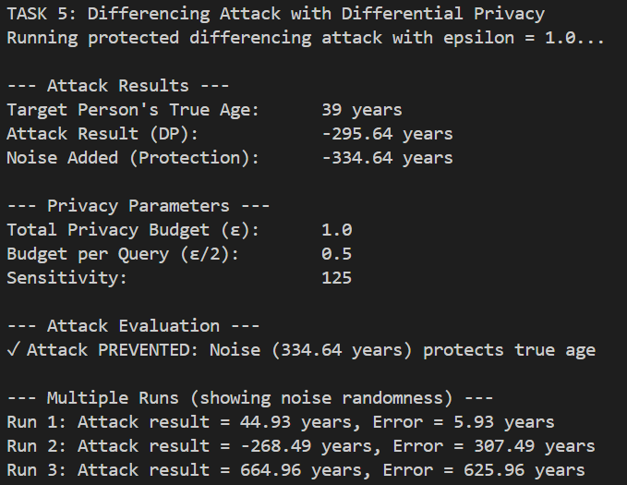
Explain: What is the sensitivity of the differencing_attack query defined above, and why?
Answer: The sensitivity is the maximum possible age (for example, 125).
Why?
- The Math: The attack calculates Total Sum of Ages minus Sum of Ages without Karrie. The result of this calculation is exactly Karrie's Age.
- The Definition: Sensitivity is the maximum amount the result can change if one person's data changes.
- The Reason: If we change Karrie's age in the database (for example, from 0 to 125), the result of the attack also changes by that exact amount.
- Conclusion: Since a person's age can mathematically be any number up to a maximum limit (like 125), the sensitivity is equal to that maximum limit.

